NOVOS TESTES REALIZADOS

--- Non-linear least squares estimation of ARFIMA(1,0,0) model ----
The estimation sample is: 1995 (7) - 2004 (1)
The dependent variable is: LEMBI+ BZ JPM2 (AZ REG1.xls)

Coefficient Std.Error t-value t-prob
AR-1 0.914481 0.03967 23.1 0.000
Constant -3.51558 0.1539 -22.8 0.000
BB HY Spd JPM 0.226467 0.02974 7.62 0.000

log-likelihood 95.6829319
no. of observations 103 no. of parameters 4
AIC.T -183.365864 AIC -1.78025111
mean(LEMBI+ BZ JPM2) -2.66166 var(LEMBI+ BZ JPM2) 0.128094
sigma 0.0965113 sigma^2 0.00931444

BFGS using numerical derivatives (eps1=0.0001; eps2=0.005):
Strong convergence
Used starting values:
0.88758 -3.4254 0.22741

Portmanteau statistic for residuals
Autocorrelation function (ACF) from lag 1 to 36:
0.14832 -0.066920 -0.026690 0.037229 0.0028659 0.068616
0.058983 0.032604 -0.0022899 -0.011967 -0.077868 0.011713
0.081118 0.048371 -0.081323 -0.094164 -0.22122 -0.13419
-0.12879 0.10747 0.013221 -0.12301 -0.10828 -0.11763
-0.079196 0.061683 0.013458 -0.10651 0.030222 0.059959
-0.13639 -0.064702 0.065106 0.16786 0.034214 -0.0022251
Partial autocorrelation function (PACF):
0.14832 -0.090919 -0.0024508 0.036960 -0.011899 0.077975
0.037807 0.027305 -0.00061814 -0.011457 -0.079221 0.029168
0.059017 0.021966 -0.080176 -0.067562 -0.21457 -0.092296
-0.14969 0.12282 -0.023656 -0.099028 -0.035918 -0.10658
-0.036581 0.061758 -0.022174 -0.11239 0.095696 0.055859
-0.10771 -0.028850 -0.013253 0.075815 -0.015946 -0.032463
Portmanteau(36): Chi^2(35)= 37.125 [0.3713]

Normality test for residuals
Observations 103
Mean 2.3588e-006
Std.Devn. 0.095570
Skewness 1.3193
Excess Kurtosis 3.4479
Minimum -0.21622
Maximum 0.42269
Asymptotic test: Chi^2(2) = 80.899 [0.0000]**
Normality test: Chi^2(2) = 22.537 [0.0000]**

ARCH coefficients:
Lag Coefficient Std.Error
1 0.07858 0.1006
RSS = 0.0464391 sigma = 0.0217685

Testing for error ARCH from lags 1 to 1
ARCH 1-1 test: F(1,98) = 0.60999 [0.4367]

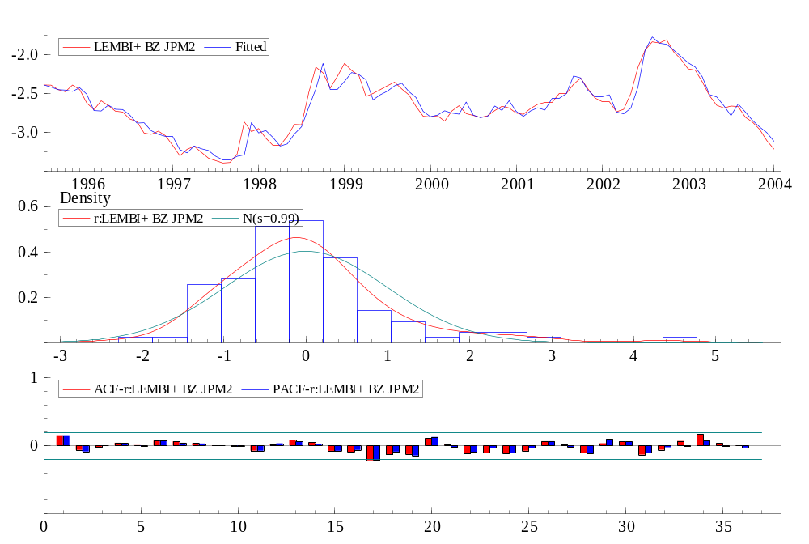

Parece realmente um AR1

---- Non-linear least squares estimation of ARFIMA(1,0,0) model ----
The estimation sample is: 1999 (2) - 2004 (1)
The dependent variable is: LEMBI+ BZ JPM2 (AZ REG1.xls)

Coefficient Std.Error t-value t-prob
AR-1 0.883167 0.05044 17.5 0.000
Constant -3.53256 0.1482 -23.8 0.000
BB HY Spd JPM 0.210901 0.02992 7.05 0.000

log-likelihood 67.8708121
no. of observations 60 no. of parameters 4
AIC.T -127.741624 AIC -2.12902707
mean(LEMBI+ BZ JPM2) -2.53865 var(LEMBI+ BZ JPM2) 0.0879649
sigma 0.0794071 sigma^2 0.00630548

BFGS using numerical derivatives (eps1=0.0001; eps2=0.005):
Strong convergence
Used starting values:
0.83000 -3.3719 0.20566

---- Non-linear least squares estimation of ARFIMA(1,0,0) model ----
The estimation sample is: 1995 (7) - 2002 (2)
The dependent variable is: LEMBI+ BZ JPM2 (AZ REG1.xls)

Coefficient Std.Error t-value t-prob
AR-1 0.908055 0.04385 20.7 0.000
Constant -3.43631 0.1806 -19.0 0.000
BB HY Spd JPM 0.209839 0.03920 5.35 0.000

log-likelihood 72.7898343
no. of observations 80 no. of parameters 4
AIC.T -137.579669 AIC -1.71974586
mean(LEMBI+ BZ JPM2) -2.72248 var(LEMBI+ BZ JPM2) 0.0991292
sigma 0.0986524 sigma^2 0.0097323

BFGS using numerical derivatives (eps1=0.0001; eps2=0.005):
Strong convergence
Used starting values:
0.89612 -3.3709 0.21677

--- Non-linear least squares estimation of ARFIMA(1,0,0) model ----
The estimation sample is: 1999 (2) - 2002 (2)
The dependent variable is: LEMBI+ BZ JPM2 (AZ REG1.xls)

Coefficient Std.Error t-value t-prob
AR-1 0.827328 0.05884 14.1 0.000
Constant -3.19849 0.1738 -18.4 0.000
BB HY Spd JPM 0.136119 0.03779 3.60 0.001

log-likelihood 48.1901271
no. of observations 37 no. of parameters 4
AIC.T -88.3802542 AIC -2.38865552
mean(LEMBI+ BZ JPM2) -2.59368 var(LEMBI+ BZ JPM2) 0.0283093
sigma 0.0676377 sigma^2 0.00457486

BFGS using numerical derivatives (eps1=0.0001; eps2=0.005):
Strong convergence
Used starting values:
0.79913 -2.6366 0.011642

Portmanteau statistic for residuals
Autocorrelation function (ACF) from lag 1 to 36:
0.059702 -0.010596 0.030463 -0.18129 -0.15620 -0.023104
-0.0036416 -0.066925 -0.032974 -0.066011 0.10454 -0.079494
-0.18596 0.12539 0.034281 -0.12057 -0.093275 -0.027309
-0.16838 0.042202 0.090600 0.046758 0.069384 0.086960
0.023963 0.19269 -0.019770 0.0057803 -0.012058 -0.13925
-0.044536 -0.016979 0.0074767 0.039737 -0.011602 9.5027e-007
Partial autocorrelation function (PACF):
0.059702 -0.014211 0.032073 -0.18613 -0.13729 -0.014797
0.0075706 -0.094515 -0.083247 -0.099915 0.11722 -0.12714
-0.24067 0.089151 0.054690 -0.16032 -0.26497 -0.081293
-0.12374 -0.024698 -0.12067 -0.12197 -0.032686 0.067766
-0.15978 0.095361 -0.0041171 0.044862 -0.16191 -0.15080
-0.012059 -0.045712 -0.036354 -0.063635 -0.16362 -0.015726
Portmanteau(36): Chi^2(35)= 22.988 [0.9408]

Normality test for residuals
Observations 37
Mean 3.3228e-006
Std.Devn. 0.065784
Skewness -0.41711
Excess Kurtosis -0.10383
Minimum -0.17476
Maximum 0.10299
Asymptotic test: Chi^2(2) = 1.0895 [0.5800]
Normality test: Chi^2(2) = 1.3472 [0.5099]

ARCH coefficients:
Lag Coefficient Std.Error
1 0.16231 0.1735
RSS = 0.00126013 sigma = 0.00627526

Testing for error ARCH from lags 1 to 1
ARCH 1-1 test: F(1,32) = 0.87559 [0.3564]

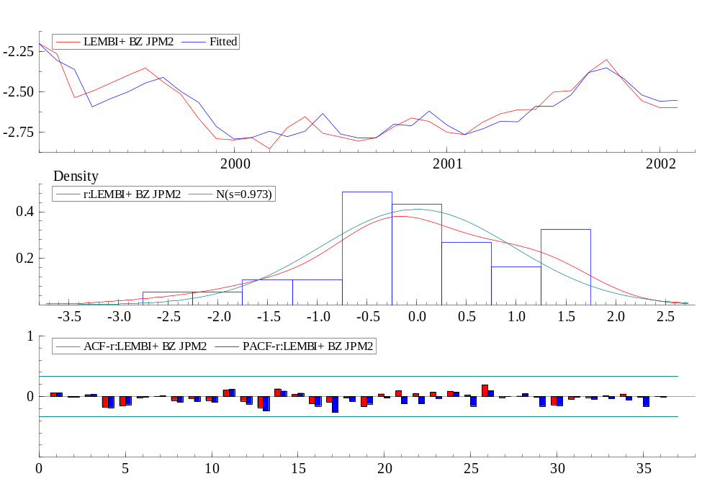

---- Non-linear least squares estimation of ARFIMA(1,0,0) model ----
The estimation sample is: 1995 (7) - 2002 (12)
The dependent variable is: LEMBI+ BZ JPM2 (AZ REG1 men 3.xls)

Coefficient Std.Error t-value t-prob
AR-1 0.915200 0.04209 21.7 0.000
Constant -3.48558 0.1843 -18.9 0.000
BB HY Spd JPM 0.209680 0.04155 5.05 0.000

log-likelihood 80.7184437
no. of observations 90 no. of parameters 4
AIC.T -153.436887 AIC -1.7048543
mean(LEMBI+ BZ JPM2) -2.74138 var(LEMBI+ BZ JPM2) 0.0898139
sigma 0.0998013 sigma^2 0.00996031

BFGS using numerical derivatives (eps1=0.0001; eps2=0.005):
Strong convergence
Used starting values:
0.88689 -3.3485 0.19999

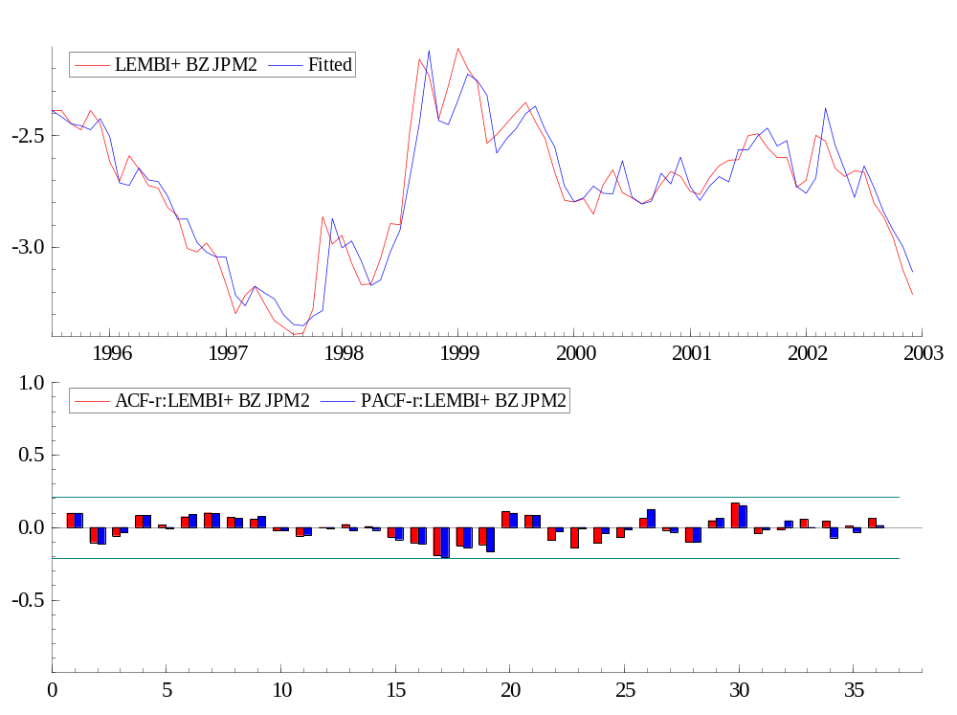

Se fosse a partir de 99 seria isso…
---- Non-linear least squares estimation of ARFIMA(1,0,0) model ----
The estimation sample is: 1999 (1) - 2002 (12)
The dependent variable is: LEMBI+ BZ JPM2 (AZ REG1 men 3.xls)

Coefficient Std.Error t-value t-prob
AR-1 0.885433 0.05256 16.8 0.000
Constant -3.31347 0.2024 -16.4 0.000
BB HY Spd JPM 0.132614 0.04450 2.98 0.005

log-likelihood 55.7789811
no. of observations 48 no. of parameters 4
AIC.T -103.557962 AIC -2.15745755
mean(LEMBI+ BZ JPM2) -2.64584 var(LEMBI+ BZ JPM2) 0.0404556
sigma 0.0773263 sigma^2 0.00597936

BFGS using numerical derivatives (eps1=0.0001; eps2=0.005):
Strong convergence
Used starting values:
0.74370 -2.5836 -0.017237

---- Non-linear least squares estimation of ARFIMA(1,0,0) model ----
The estimation sample is: 1995 (7) - 2000 (8)
The dependent variable is: LEMBI+ BZ JPM2 (AZ REG1 men 25.xls)

Coefficient Std.Error t-value t-prob
AR-1 0.914700 0.05292 17.3 0.000
Constant -3.72460 0.2380 -15.7 0.000
BB HY Spd JPM 0.290696 0.05989 4.85 0.000

log-likelihood 53.8042254
no. of observations 62 no. of parameters 4
AIC.T -99.6084507 AIC -1.60658791
mean(LEMBI+ BZ JPM2) -2.80889 var(LEMBI+ BZ JPM2) 0.103618
sigma 0.103276 sigma^2 0.0106659

BFGS using numerical derivatives (eps1=0.0001; eps2=0.005):
Strong convergence
Used starting values:
0.85745 -3.7790 0.37183

ESPECIFICAÇÃO DIFERENTE
---- Non-linear least squares estimation of ARFIMA(1,0,0) model ----
The estimation sample is: 1995 (7) - 2004 (1)
The dependent variable is: LEMBI+ BZ JPM2 (AZ REG1.xls)

Coefficient Std.Error t-value t-prob
AR-1 0.955669 0.03193 29.9 0.000
Constant -2.97164 0.2921 -10.2 0.000
BBB-BB HY Spd JPM 0.177882 0.05640 3.15 0.002

log-likelihood 77.925655
no. of observations 103 no. of parameters 4
AIC.T -147.85131 AIC -1.43544961
mean(LEMBI+ BZ JPM2) -2.66166 var(LEMBI+ BZ JPM2) 0.128094
sigma 0.11467 sigma^2 0.0131493

BFGS using numerical derivatives (eps1=0.0001; eps2=0.005):
Strong convergence
Used starting values:
0.93154 -2.7539 0.13279

Portmanteau statistic for residuals
Autocorrelation function (ACF) from lag 1 to 36:
0.36875 0.079389 0.027951 0.080670 -0.053043 -0.066791
-0.0048893 0.021223 0.014894 0.035476 -0.0049816 -0.0012363
0.058772 0.080589 -0.12003 -0.13570 -0.17515 -0.19594
-0.14797 0.022479 0.070342 0.00073729 -0.064250 -0.078055
-0.069476 0.047500 0.0095812 -0.079981 -0.090567 0.00066664
-0.077593 -0.11039 0.056456 0.12101 0.024881 -0.026874
Partial autocorrelation function (PACF):
0.36875 -0.065491 0.024304 0.077504 -0.12972 -0.0020474
0.032038 0.00035924 0.023275 0.029897 -0.048936 0.017916
0.069767 0.032258 -0.18457 -0.027449 -0.14805 -0.11603
0.016246 0.089695 0.027711 -0.042637 -0.083897 -0.080763
-0.0035211 0.13917 -0.045936 -0.091412 -0.024752 0.00084967
-0.072578 -0.023162 0.10263 -0.040128 -0.068497 -0.017701
Portmanteau(36): Chi^2(35)= 43.892 [0.1440]

Normality test for residuals
Observations 103
Mean -8.5938e-007
Std.Devn. 0.11355
Skewness 1.1400
Excess Kurtosis 1.8201
Minimum -0.26818
Maximum 0.39246
Asymptotic test: Chi^2(2) = 36.526 [0.0000]**
Normality test: Chi^2(2) = 22.341 [0.0000]**

ARCH coefficients:
Lag Coefficient Std.Error
1 0.23445 0.09807
RSS = 0.0616525 sigma = 0.025082

Testing for error ARCH from lags 1 to 1
ARCH 1-1 test: F(1,98) = 5.7149 [0.0187]*

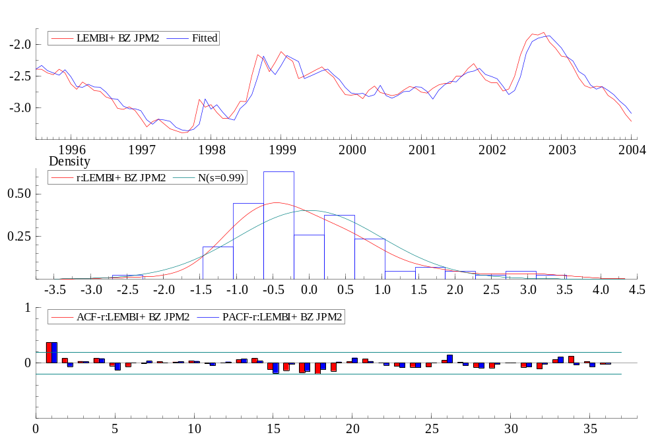

Precisa de mais informação,,, Agora com o BBB

---- Non-linear least squares estimation of ARFIMA(1,0,0) model ----
The estimation sample is: 1995 (7) - 2004 (1)
The dependent variable is: LEMBI+ BZ JPM2 (AZ REG1.xls)

Coefficient Std.Error t-value t-prob
AR-1 0.912316 0.03946 23.1 0.000
Constant -3.55592 0.1551 -22.9 0.000
BBB-BB HY Spd JPM 0.178652 0.04771 3.74 0.000
BBB HY Spd JPM 0.255561 0.03715 6.88 0.000

log-likelihood 96.4884411
no. of observations 103 no. of parameters 5
AIC.T -182.976882 AIC -1.77647458
mean(LEMBI+ BZ JPM2) -2.66166 var(LEMBI+ BZ JPM2) 0.128094
sigma 0.0962371 sigma^2 0.00926158

BFGS using numerical derivatives (eps1=0.0001; eps2=0.005):
Strong convergence
Used starting values:
0.88686 -3.3887 0.13212 0.23846

Portmanteau statistic for residuals
Autocorrelation function (ACF) from lag 1 to 36:
0.13118 -0.10497 -0.034875 0.024296 0.0094061 0.062155
0.085752 0.022048 0.024021 -0.013464 -0.078903 0.015263
0.086630 0.021659 -0.096452 -0.069924 -0.19937 -0.13087
-0.12282 0.11817 -8.4814e-005 -0.14999 -0.11843 -0.12771
-0.070233 0.076571 0.030965 -0.13173 0.062920 0.055337
-0.15572 -0.064758 0.068992 0.16674 0.037806 0.023296
Partial autocorrelation function (PACF):
0.13118 -0.12431 -0.0031886 0.017409 -0.0013441 0.067762
0.071364 0.014002 0.040941 -0.019010 -0.074271 0.031122
0.053599 -0.0042044 -0.087947 -0.046820 -0.21069 -0.096508
-0.16527 0.12132 -0.058086 -0.11562 -0.058536 -0.10976
-0.047068 0.082303 -0.0058381 -0.12168 0.14385 0.030350
-0.10847 -0.029899 -0.018132 0.089591 0.0062354 -0.014914
Portmanteau(36): Chi^2(35)= 40.240 [0.2494]

Normality test for residuals
Observations 103
Mean -4.8689e-008
Std.Devn. 0.094825
Skewness 1.3633
Excess Kurtosis 3.6845
Minimum -0.20633
Maximum 0.43018
Asymptotic test: Chi^2(2) = 90.171 [0.0000]**
Normality test: Chi^2(2) = 23.679 [0.0000]**

ARCH coefficients:
Lag Coefficient Std.Error
1 0.066521 0.1012
RSS = 0.0470489 sigma = 0.0220236

Testing for error ARCH from lags 1 to 1
ARCH 1-1 test: F(1,97) = 0.43189 [0.5126]

